**Market and economic feasibility study**

**1. Introduction**

This document highlights the proposed market and economic feasibility study, as well as the main nuances and reasoning pertinent to the fundamental approach of the second delivery of the Garduino project, through which the corporate strategic profile and the needs and capacities of the project are evaluated from a financial and market perspective.

Throughout the report, the criteria of choice and study followed throughout the decision-making of the project will be detailed, and the fundamental concepts of the theory of the economic-business environment on which it is based will be provided.

**2. The nature of the company and product**

We begin by analyzing the general nature of the company. Knowing the most primary parameters of the same one allows to create a general conception of the ideas, purposes and mentality of its directive.

**2.1 General information**



The company behind Garduino is a start-up dedicated to the development and implementation of industrial IT solutions for the gardening and -potentially- agricultural sector. It is a Limited Company of 5 workers (and therefore would be included in the category of microenterprise), has a share capital of less than €10,000 and it is estimated that its turnover, in its future regularity and stability, will be below €2 million.

|  |  |  |
| --- | --- | --- |
|  | **Number of workers** | **Income** |
| **Micro-enterprise** | **Up to 10** | **< 2.000.000€** |
| Small enterprise | Up to 50 | < 10.000.000€ |
| Medium enterprise | Up to 250 | < 50.000.000€ |
| Big enterprise | > 250 | ≥ 50.000.000€ |

**2.2 Mission of the company**

One of the key elements, as far as the self-definition of the company is concerned, is its mission. The mission is the definition, on the part of the directors of the company itself, of what the company's activity consists of and what they are today, as well as their vision for the long term.

In the case of Garduino's company, the mission is:

“To provide the agricultural sector and private gardeners with the technological tools necessary to cover all those automated tasks, and allow them to focus on the most relevant and enriching aspects of their activity.”

**2.3 Strategic objectives of the company**

The strategic purposes of the company, when properly defined, allow it to overcome the gap between its current situation and states in the expected medium-long term.

Being a small company of recent creation, its main priority today is to find a niche and stay parked in an unexplored market, generating a clientele and promoting their product and brand. On a more specific level, its main objective is to satisfy the needs of its future customers, in order to establish and reaffirm favourable commercial relations.

**2.4 Values and Corporate Social Responsibility Policy**

The social responsibility of a corporation is based on a series of values, principles and beliefs that govern its policies and positions of action.

The company tries to remain "at the forefront" in terms of machinery and technical means, considering it a commitment to technological progress with a strong initiative in providing a range of services and products to the customer, prioritizing the technical aspect and suitability.

It seeks proximity to the customer and the high degree of customization, away from the standardization and generic treatment of large companies that do not have the same degree of proximity as SMEs.

In addition, the focus of the company's activity is the provision of products related to the optimization and appropriate use of resources, both human and material, with the social and environmental impact that this entails.

**3. External analysis of the company**

In order to know the situation of the company, it is essential to study its environment, as well as the competitive structure of the sector in which it operates, the threats and opportunities to which it is exposed, and a general recognition of the agents involved in the ecosystem to which it belongs.

**3.1 Company-specific environment**

The specific environment of a company constitutes the set of factors that influence the companies belonging to the same sector, endowed with common and concurrent characteristics in the same type of activity.

* **Competitors:** 
  + Companies dedicated to the development of IOT solutions in the field of gardening, domotics and / or agriculture.
* **Customers:** 
  + Individuals with gardening activity.
  + Gardening shops.
* **Suppliers:** 
  + Hardware suppliers.
* **Substitute products:** 
  + Automated irrigation systems.
  + Conventional forms of irrigation in greater economic feasibility.
  + Planting facilities with in-built technology to ease their sustenance.

**3.2 Competitive structure of the sector**

We analyze the competitive structure of the sector based on Porter's theory of the five forces:

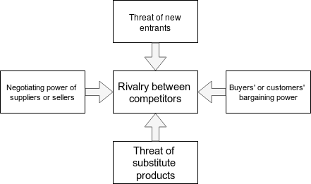

* **Buyers' or customers' bargaining power:** The negotiating power of the clients is moderately high or at least to be taken into consideration, due to the fact that the company is still not very well established in the market.
* **Negotiating power of suppliers or sellers:** The bargaining power of suppliers is extremely low, given the large number of suppliers of the same type of hardware existing in global markets.
* **Threat of new entrants:** The threat of new competitors offering technical improvements in the sector's products is medium-high, given the dynamics and innovation of technological advances.
* **Threat of substitute products:** The threat of substitute products, given the characteristics of the sector in its current state, is low.
* **Rivalry between competitors:** As an installation process is involved, competitors are excluded from global markets, significantly reducing the degree of competition in this regard.

**3.3 Company opportunities and threats**

In the study of the company's opportunities, the company's adaptability and flexibility stand out.

As it is a start-up company with small dimensions, there are very few barriers to a high degree of personalisation of the products (a smaller customer base, in the current phase of expansion of the same, allows avoiding standardisation processes and focusing on the customer at a more particular level).

The greatest threat it faces, on the other hand, is the existence of companies capable of employing greater resources in proposing solutions of a similar nature, especially in terms of hardware (both in quality and quantity).

**3.4 Main actors of the ecosystem**

The company's ecosystem has the following agents:

* Companies predominant in the development of solutions for the agricultural sector.
* Predominant companies in the development of solutions for domotics.
* Particular clients.
* Shop clients.
* Hardware providers.
* Technology and research sector: Technology is constantly changing. This gives rise to new opportunities, both in terms of the evolution, improvement and adaptation of the product, as well as the possibility of the appearance of substitute products or competitors of the same. This is a double-edged sword, as it brings with it a current to which, if it is similar, the company would find a series of competitive advantages and opportunities, while, if it is ignored, it could lead to the appearance of problems and threats.
* Media (conventional and social networks).

**4. Internal analysis of the company**

The knowledge of the value chain, of the main resources and capacities of the company allows us to know its internal situation, and provides us with a suitable profile for strategic analysis and decision making, when combined with the external analysis carried out.

**4.1 The value chain**

The value chain consists of disaggregating all the activities that the company carries out on a regular basis, along the entire procedure necessary to achieve the elaboration and trading of a good or to carry out the provision of a service.

* **Primary activities:**
  + Internal logistics: Storage, transport and use of the physical components involved.
  + Operations: Elaboration of products, installation of devices, configuration...
  + External logistics: Transport and distribution to the client.
  + Marketing and sales: There should be a marketing plan that favors the number of sales and gives visibility to potential customers.
  + Maintenance and post-sales service: Customer support, maintenance of installations, management and reconfiguration of devices...
* **Support activities:**
  + Provisioning: Hardware purchase.
  + Technological development: Development of new types of devices, integration of new sensors in the installations, software improvements...
  + Human resources: Management of work teams. Agile methodologies are used to facilitate this process.
  + Corporate infrastructure: Planning, financial control, accounting...

**4.2 Key resources and capacities**

The resources and capacities of the company are:

* Reduced size, which allows to reduce the degree of standardization and increase the degree of customization and specialization.
* Potential proximity to the local customer, local stores…
* Professionals with the ability to specialise in the technical fields of product development and maintenance.

**4.3 Competitive advantage**

Consequently, the company can produce highly personalised products to adapt to the specific profile of each customer, while having sufficient flexibility and closeness to the consumer to focus on a particular treatment for the subsequent maintenance of the systems.

**4.4 SWOT analysis**

The SWOT model is a popular strategic analysis tool. As such, it allows to establish a strategy based on the knowledge of a series of external factors, qualified as the defenses, threats, strengths and opportunities available to a company. This technique allows to group, in a simple way, the result of the combination between the external analysis and the external analysis of the company:

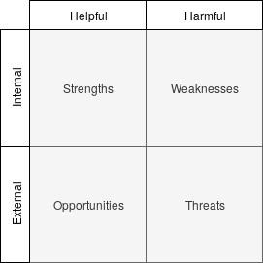

* **Strengths:**
  + Small size for versatility and flexibility.
  + Use of cutting-edge technologies.
  + Professionals in the field of information technology.
* **Opportunities:**
  + Establishing close relationships with customers and redistributors.
  + Introducing a new type of computer solution in the automation of the gardening sector.
* **Weaknesses:**
  + Totally new to the sector.
  + Lack of a business relationship structure.
  + Little consolidated organization.
  + Low initial capital.
* **Threats:**
  + By operating in the field of technology and being this so changing, possibility of a product appearing capable of replacing it.
  + Large companies have greater investment capacity to compete in this market.

**5. Strategic management**

Based on the information obtained about the company, we will try to stipulate the strategic aspects of it.

**5.1 Competitive strategy**

The company should follow a clear strategy of product differentiation, as it prioritizes quality and places its efforts and investments in the technical strength to give a product with unique characteristics, in addition to conforming to the exact specifications of each client in particular.

In addition, it will follow a niche specialist strategy. It is a company that, being a follower in a market, chooses to differentiate itself from the rest by specialising in a sub-market, or "market niche", with possibilities, in which it can reach a large market share. In this case, it separates itself from the public of the agricultural sector to offer speciality in the field of gardening.

**5.2 Growth and development management**

The company must carve a niche in the market where it operates, with a small but progressive growth, establishing and strengthening its ties with customers and redistributors.

In the future, when the company reaches its peak from the perspective of its past planning, and if there are no exceptionally anomalous changes, it will be able to expand into new market niches related to industrial and electronic computing to present solutions to a variety of professional and domestic environments.

**6. Marketing management**

The company needs a marketing and communication plan in order to promote its sales volume and give visibility to its product and brand.

**6.1 Marketing goals**

The main marketing objectives of Garduino are:

* Promote the notoriety of the brand and/or product marketed among the target audience.
* Promote knowledge of product attributes, characteristics and performance, as well as competitive differentiation with respect to the same product market.
* Establish and strengthen a connection between company and target audience, carrying out different strategies to familiarize and bring the user closer to the brand and product in marketing.
* To constitute, with regard to the potential client, one of the alternatives of the market to contemplate when acquiring a product of the nature of the article in question.

**6.2 Public of interest**

The public of interest is understood to be the group of publics or audiences targeted by a marketing campaign. It should be noted that we can differentiate between primary and secondary audiences, depending on whether or not they are involved as potential end consumers.

As such, the company dichotomizes between two kinds of profiles of potential clients to whom it focuses its communication strategy:

* The first customer profile should be any interested person in controlling the irrigation and the health of the plants in their houses/garden in a comfortable, efficient and automated way. The population segment defined as target audience is broad and determined by these very simple conditions. It can be focused both on private gardening and on a larger scale. Volume limits are set by the customer's business model or personal use.
* Likewise, the company bets on the provision to redistributors and garden shops, prioritizing the establishment of commercial relationships with large garden shops and home and domotics products, which have a wide commercial reach, a broad user base and sufficient means of promotion and advertisment to increase the visibility of the product.

**6.3 Communication techniques**

The communication techniques used for the promotion and diffusion of brand and product will be the following:

* **Advertising in conventional media:** transmission of the advertising message through advertisements and programmed messages in media such as television, radio...
* **Sales promotion:** alterations in the sales lot or in the price of the product in order to attract consumers.
* **Fairs and exhibitions:** Participation and presence in fairs and exhibitions to make oneself known or to collaborate in the transmission of a message.
* **Sponsorship:** Association with other initiatives, businesses, causes and figures in order to carry out an exhibition of the brand in certain contexts, as well as to carry out an exploitation of the image associated with the activity in question, and to try to carry out a commercial exploitation of activities derived from the event.
* **Personal sale:** Presential presentation and sale of the commercial to the client of the product in a physical space. This technique is usually carried out in commercial spaces, by means of informative and/or exhibition stands where the product is presented to the client and it is a question of negotiating a closing of sales with the same one.
* **Website:** Use of an informative web space where relevant company information can be announced, as well as support for online sales and subscription to other types of digital communications.
* **Blogs:** Use of web spaces structured through a system of publication of articles and news over time, which can allow different degrees of participation by users, and through which it is intended to capture an interest in the user and redirect traffic to the main website or digital content that presents information on products that may be of interest to the potential consumer.
* **Social networks:** Use of social network platforms to maintain a system of communication and promotion with the user, in addition to being a powerful tool for the approach and contact with it.
* **E-mailing:** newsletter system that transmits information and advertising relevant to the brand and product through e-mail.

**6.4 Communication model**

The communication model presented by Garduino is the multiphase model. This communication model not only involves commercials and experts or opinion leaders as influential and diffusion figures, but it will be the target public itself that will assume a role of active participation within the communicative process. These will act as ”ambassadors” of a product, brand, good, service…

This model, in turn, has a wide affinity with inbound marketing positioning strategies.

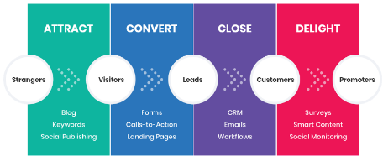

This model manifests itself strongly in the growing digital and social network environments, and

the search for the implementation of this kind of model by companies is evident in the incitement for the user to participate in one of the dissemination campaigns through these environments.

**Attract:** In this first phase of Inbound Marketing we look for people to reach our digital media (blog, social media, etc.) above those of the competition. We will increase our web traffic through the interest generated by our content. We will use:

* SEO
* Social Networking
* Third party recommendations

**Convert:** In this second phase we seek to get leads, that is, that the visitors that we may have had on our website come to register. In other words, we look for them to leave us their data to classify its importance within our database. We will use:

* CTAs
* Lead Magnets
* Forms
* Chat Bots

**Close:** Once that we have leads registered on our site it is time to close the conversion to customer: we want them to buy our product and/or service. We will offer relevant information and value for the user to choose us instead of other offers that may have in the market. In this step, we will have to understand once again the phase in which our user is within the buyer journey.

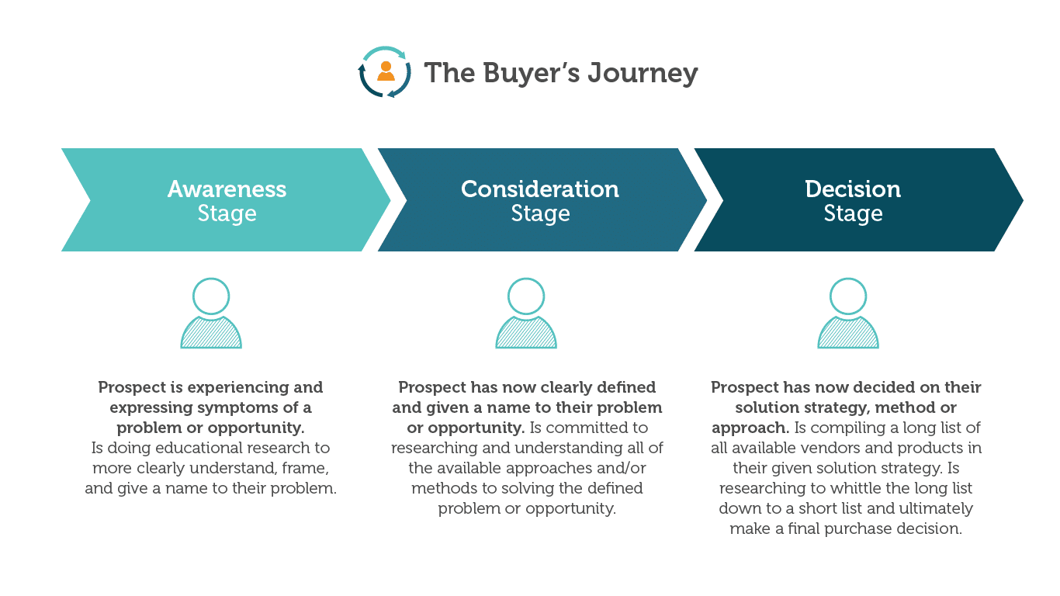

**Delight:** We want our clients to be prescriptors of our brand. We have made the user part of our database. Now, we want the customer to repeat, to trust us, to prefer us over the competition or even not to look for more purchase options.

It's time to surprise the client, offer solutions to their problems and give them a service out of the ordinary. We have to position ourselves in the mind of the consumer as the brand that gives the most information, the one that cares the most and the one that has the best customer service.

We must prioritize customer service and maintain communication channels that show the most important news and generate the feeling of cordial communication, close and useful at all times.

**7. Economic feasibility study**

We will study the balance of revenues (establishing the means of monetization of the business model) and expenses in order to ensure the economic feasibility of the corporate activity, as well as study the best commercial option in financial terms for the project.

**7.1 Sources of income**

The main sources of revenue for the business model will be:

* Sale of the product (software + hardware) to individuals
* Sale of the product (software + hardware) to distributors
* Installation service
* Maintenance service
* Special customization service, changes, configuration...

**7.2 Costs of the project**

* Application development costs: development salaries, planification.
* Maintenance costs: maintainance salaries, transport, provisioning and planification.
* Platform adaptation, portability and interoperability.
* UI Design & Graphics.
* Costs of all additional features that will be added in the future, investment in investigation and upgrades of the product.
* Marketing campaign: The stipulated communication campaign will be followed, whose investment will be proportional to the level of income generated at each moment of the life phase of the product.
* Operational costs: Costs for the hardware parts of the prototypes, electricity costs and maintenance of the computers with which the project is programmed.

**7.3 Economic analysis**

The accounting of the project for the following four years is:

* Subida IPC / Coste de vida en salarios

|  |  |  |  |  |
| --- | --- | --- | --- | --- |
| **Year** | 1 | 2 | 3 | 4 |
| **Employee salaries** | 12.600€ | 12.600€ | 21.000€ | 21.000€ |
| **Employees** | 5 | 5 | 5 | 5 |
| **Total employee costs** | **63.000€** | **63.000€** | **105.000€** | **105.000€** |
| **Unit cost per device production** | 100€ | 100€ | 100€ | 100€ |
| **Units produced** | 300 | 600 | 1000 | 1500 |
| **FIxed costs for exploitation** | 7.000€ | 7.000€ | 7.000€ | 7.000€ |
| **Production costs** | **37.000€** | **67.000€** | **107.000€** | **157.000€** |
| **Marketing investment** | **3.000€** | **5.000€** | **5.000€** | **5.000€** |
| **Sales price (B2C)** | 400€ | 350€ | 300€ | 300€ |
| **Sales price (B2B)** | 200€ | 200€ | 200€ | 200€ |
| **Sales volume (B2C)** | 50 | 100 | 200 | 400 |
| **Sales volume (B2B)** | 200 | 400 | 800 | 1200 |
| **Units in stock** | 50 | 150 | 150 | 50 |
| **Sales revenue** | **60.000€** | **115.000€** | **220.000€** | **360.000€** |
| **Maintenance revenue per sale** | 25€ | 50€ | 50€ | 50€ |
| **Actual maintenance revenue** | **6.250€** | **25.000€** | **50.000€** | **80.000€** |
| **TOTAL** | **-36.750€** | **5.000€** | **53.000€** | **173.000€** |

* Trimestres (más específico)
* SS en salarios
* Costes de marketing más realistas (más inversión)
* Hacer más énfasis en por qué los precios son los que son (B2C y B2B)
* Incrementar los costes fijos en base al embalaje
* Se pueden bajar los precios B2C (primer año)
* Echar vistazo al tema del mantenimiento (sale rentable incrementar los precios por año para cubrir gastos de servidores, etc.?)
* Contemplar como alternativa emplear el año 0 para las inversiones iniciales
* Desglosar marketing investment
* Desglosar costes + etc

In the project blast-off, an initial investment of **103.000€** will be required.

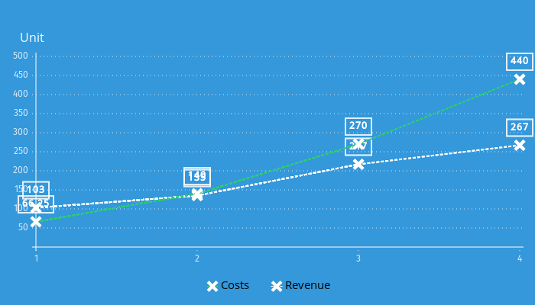

* **NPV:**

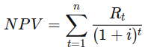

The calculation of the Net Present Value with a discount rate of 10% over the next 4 years is 25,704.15€. Since this value is greater than 0, it is understood that the investment is profitable.

* **ROI:**

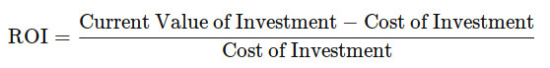

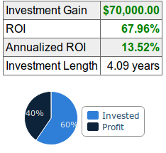

* **IRR:**

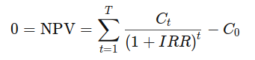

The calculation of the Internal Rate of Return for the following four years results in 15.634%.

* ROI
* NPV
* Payback
* Cifras/cash flow